Project:
HAUNTON PV PLANT
Title:
General Technical Description
Document Nº: |  | 227-007-F-E-00015 |  |  | Issue: |  | 1
Subject of study: |  |  | First issue |  | Date: | 12-07-2023
 | Prepared: |  |  | RDL
 | Revised: |  |  | ECU
 | Approved: |  |  | MDT

CLASIFICATION
Contains information for the design of structures, systems or components: YES NO
Design verification: Not applicable Head of O.U./Supervisor Verifier Level 1 Level 2
MODIFICATION CONTROL
Edition | Modifications
1 | First Issue.
PRELIMINARY OR PENDING INFORMATION
Edition | Sections | Concept | State
DISTRIBUtion
External |  | Internal | Nº copies/Support
METKA |  | MZH, GGG, RDL, MZZ, ECU, MDT | 1 /.pdf

1. INTRODUCTION 1-3
2. INVOLVED PARTIES INFORMATION 2-4
3. SITE AREA INFORMATION 3-5
3.1 SITE LOCATION 3-5
3.2 SITE ACCESS 3-5
3.3 CLIMATE CONDITIONS 3-6
3.4 SOIL CONDITIONS 3-6
4. SYSTEM CONFIGURATION 4-7
4.1 BASIC DESIGN 4-7
4.2 STRING VOLTAGE AND CURRENT SIZING 4-7
4.3 MPPT SIZING 4-8
4.4 DC/AC RATIO 4-9
4.5 CONFIGURATION 4-9
5. PV PLANT CHARACTERISTICS 5-12
5.1 PV MODULES 5-12
5.2 INVERTERS 5-13
5.3 POWER STATIONS 5-13
5.4 CLIENT STATION 5-14
5.5 PV STRUCTURE DETAILS 5-15
5.6 EARTHING SYSTEM 5-15
5.7 CABLING 5-16
5.8 CABLE ROUTING 5-17
5.9 LIGHTNING – OVERVOLTAGE PROTECTION 5-17
5.10 MONITORING SYSTEM 5-18
5.11 SECURITY SYSTEM 5-18
5.12 FENCE 5-18
5.13 FIRE ALARM 5-19
5.14 ACCESS ROAD 5-19
5.15 FOUNDATIONS 5-19
6. GRID CONNECTION 6-20
7. PERMANENT FACILITIES 7-20
8. CONSTRUCTION FACILITIES 8-20
9. REFERENCES 9-20

Table 1 Site Coordinates 3-5
Table 2 Design Climate Conditions 3-6
Table 3 Sungrow Inverter Parameters Values 4-7
Table 4 JKM570N-72HL4-BDV 570 Wp Parameters Values 4-7
Table 5 JKM575N-72HL4-BDV 575 Wp Parameters Values 4-8
Table 6 Haunton PV Plant Overview Configuration 4-9
Table 7 Substation 1 Configuration Haunton 4-10
Table 8 Substation 2 Configuration Haunton 4-10
Table 9 Substation 3 Configuration Haunton 4-10
Table 10 Substation 4 Configuration Haunton 4-11
Table 11 Substation 5 Configuration Haunton 4-11
Table 12 Substation 6 Configuration Haunton 4-11
Table 13 Module Model. Mechanical Characteristics 5-12
Table 14 Module Model. Electrical Characteristics 5-12
Table 15 Inverter Model 5-13
Table 16 Power Station Model 5-14
Table 17 PV Structure Model 5-15
Table 18 Cabling Characteristics 5-17
Table 19 Typical Trench Dimensions 5-17

INTRODUCTION
This document describes the PV Project named “Hauton PV Plant”, with a DC Capacity of 69,991 MWp located near to Haunton, Tamworth (United Kingdom).
The PV Project is divided into six substations:
- Substation 1, with a DC Capacity of 11,302.20 kWp
- Substation 2, with a DC Capacity of 11,426.40 kWp
- Substation 3, with a DC Capacity of 10,898.50 kWp
- Substation 4, with a DC Capacity of 12,263.67 kWp
- Substation 5, with a DC Capacity of 12,250.44 kWp
- Substation 6, with a DC Capacity of 11,850.30 kWp
This document provides a brief overview of the PV system and its main equipment and quantities, as well as the system configuration.

INVOLVED PARTIES INFORMATION
The preliminary design of the plant was undertaken by METKA-EGN and provided to EAI. The PV system and its main components and quantities (modules, inverters, power stations, structures) as well as the system configuration is preliminary defined and provided by METKA-EGN to EAI.
EAI will undertake the detailed engineering based on METKA-EGN preliminary design and the provided equipment technical information.
The design is developed following the criteria established in references [1], [2] and [3]
Grid is out of EAI’s scope of works.

SITE AREA INFORMATION

SITE LOCATION
The site is located about 37 km west of Leicester, United Kingdom. The villages of Haunton and Harlaston lie approximately 500m to the north east and 700m to the north west of the site respectively.
The site is irregular in shape and comprises agricultural fields, each separated and contained by established hedgerows with occasional trees.
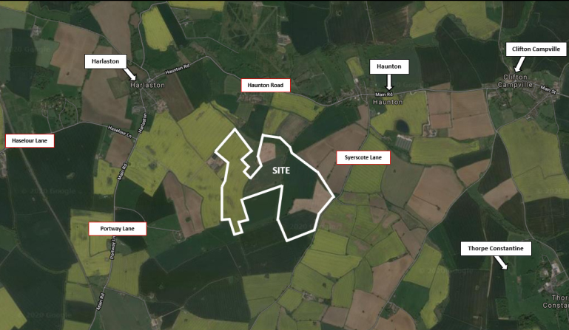
Figure 1 Site location
Project Site UTM Coordinates:
Latitude | 590558.00 m E
Longitude | 5838341.00 m N
Table 1 Site Coordinates

SITE ACCESS
The main access to the site is from Haunton road vias Syerscote Lane to the South east gate of the plant.
Another access is on from Harslaston road- Main road to the gate locate on the west side.
Figure 2 Site access

CLIMATE CONDITIONS
Next table summarizes the proposed design climate conditions:
Minimum Ambient Temperature (ºC) | -5ºC
Maximum Ambient Temperature (ºC) | +35ºC
Altitude (m) | 66 m a.s.l
Seismic Loads (m/s2) | a=0.04g
Table 2 Design Climate Conditions

SOIL CONDITIONS
The wider area of the project is slightly sloping, with levels ranging from +64mOD to +79mOD from north to south respectively.
The Geotechnical Investigation Report provided by METKA-EGN shall be consider for the detailed engineering.

SYSTEM CONFIGURATION

BASIC DESIGN
The analysis, about the efficiency of the PV installation for the Power plant, which was evaluated through PVsyst, was leaned on the following design. The pursuit is to have the PV modules unaffected from external or internal (row by row) shadings. Overall, the whole analysis was based on the features that maximize the efficiency of the park and provide sufficient clearances between the modules, the buildings and the roads for sake of operation and maintenance reasons.
The PV Plant will be designed using the following technology:
- Modules: Bifacial modules N-Type 144 Cells,
  - Jinko Tiger Pro 72HL4-BDV 570 Wp
  - Jinko Tiger Pro 72HL4-BDV 575 Wp.
- Inverters: String Inverter, SUNGROW SG350HX.
- Structure: Fixed 2V14 and 2V27, 20º angle.

STRING VOLTAGE AND CURRENT SIZING
According to Sungrow Inverter Datasheet, the following characteristics should be complied to each inverter:
SUNGROW SG350HX
AC Output Power | 353 kVA @30⁰C
MPPT Operating Voltage | 500 to 1500 V
Max. DC Voltage | 1500 V
Max. DC Continuous Current per MPPT | 30 A
Max. DC Short Circuit Current per MPPT | 60 A
Max. Number of input | 12 (Optional 14/16)
Max Nº of Independent MPPT inputs | 2
Table 3 Sungrow Inverter Parameters Values
According to PV module’s Datasheet for:
JKM570N-72HL4-BDV 570 Wp
Max. Power | 570 Wp
Open Circuit Voltage (stc) | 51,07 V
Short Circuit Current (stc) | 14,25 A
Temperature Coefficient of Voc | - 0.25 %/ºC
Temperature Coefficient of Isc | 0.046%/ºC
Table 4 JKM570N-72HL4-BDV 570 Wp Parameters Values

JKM575N-72HL4-BDV 575 Wp
Max. Power | 575 Wp
Open Circuit Voltage (stc) | 51,27 V
Short Circuit Current (stc) | 14,31 A
Temperature Coefficient of Voc | - 0.25 %/ºC
Temperature Coefficient of Isc | 0.046%/ºC
Table 5 JKM575N-72HL4-BDV 575 Wp Parameters Values
This inverter admits a maximum of 27 panels in series per string and 32 strings in parallel as shown below.
The maximum number of PV modules to be connected in series must is calculated in the most restrictive conditions: 575 Wp module and minimum ambient temperature.
For the minimum site´s temperature at -5ºC,
$$V_{OC}=55.11, @-5°C ambient temperature$$
Therefore, the maximum voltage in open circutuit per string for 27 Modules-string is:
$$V_{str,max}=1490.67<1500$$
For the maximum site’s temperature, at +35°C, the maximum Isc, max of each string is,
$$Isc_\max{=14.38, @+35°C ambient temperature}$$
Each MPPT of the inverter is configured with to 2 strings, so the total MPPT input DC shortcircuit current is valid for the inverter,
$${I_{inv,dc,Isc,max}=14.38*2=28.76<60A}$$
This inverter accepts a maximum of 16 pairs of 2 MPPT independent inputs, so it is possible to configure up to 32 strings per inverter.

MPPT SIZING
The MPPT Operating Voltage Range of each Inverter is 500V ~ 1500V. For a 27 Modules-string the Maximum Power Point Voltage, in STC conditions is
$$V_{MPPTstc}=Nº Modules per String*V_{MP}= 27*42.44=1145.88 V$$
which means that the above voltage window is fulfilled and gives a wide operational range to the Inverter.

DC/AC RATIO
The project’s DC capacity is 69.991,56 kWp and the number of modules used to reach this capacity is 61.128 pcs x 570 Wp and 61.128 pcs 575 Wp.
A number of 154 Sungrow String Inverters SG350HX are used to generate a Nominal Installed AC Capacity of 54.208 kW max output power, therefore the average DC/AC Ratio of the PV Plant is 1,291 @30ºC.

CONFIGURATION
The electrical plan configuration developed according to the general plant layout, ref [4], is
OVERVIEW PV PLANT CONFIGURATION
PV MODULE | JINKO TIGER PRO 72HL4-BDV 570 WP
PV MODULE | JINKO TIGER PRO 72HL4-BDV 575 WP
Nº PV MODULES PER STRING | 27
TOTAL Nº STRINGS | 4,528
TOTAL Nº POWER STATIONS | 6xMVS8960-LV
TOTAL Nº INVERTERS | 154
TOTAL Nº 2V14 STRUCTURES | 216
TOTAL Nº 2V27 STRUCTURES | 2,156
TOTAL Nº 570 WP MODULES | 61,128
TOTAL Nº 575 WP MODULES | 61,128
NAMEPLATE DC CAPACITY | 69,991.56 kWp
GRID VOLTAGE LEVEL | 132 kV
AC POWER (NOM) AT 40ºC | 49,280 kW
AC POWER (MAX) AT 30ºC | 54,208 kW
DC/AC (NOM) RATIO | 1.420
DC/AC (MAX) RATIO | 1.291
Table 6 Haunton PV Plant Overview Configuration

The configurations for each of the substations are:
SUBSTATION 1
POWER STATION | 8960 KVA
MODULE | Jinko Tiger Neo N-type 72HL4-BDV 575 WP
INVERTER | 25 x Sungrow SG350HX (320 kVA @40ºC)
MODULES/STRING | 27 Modules
Nº Strings | 22 inverters x 29 string
Nº Strings | 3 inverters x 30 string
Nº Strings | 728 Strings
Total DC Capacity | 728 x 27 Modules x 575 W -> 11.302,20 kW
Total AC Capacity | 25 Inverters x 320 kVA -> 8.000 kVA
DC/AC Ratio (@40ºC) | 1,413
Table 7 Substation 1 Configuration Haunton
SUBSTATION 2
Transformer | 8960 KVA
Modules | Jinko Tiger Neo N-type 72HL4-BDV 575 WP
Inverter | 25 x Sungrow SG350HX (320 kVA @40ºC)
Modules / String | 27 Modules
Nº Strings | 14 inverters x 29 string
Nº Strings | 11 inverters x 30 string
Nº Strings | 736
Total DC Capacity | 736 x 27 Modules x 575 W -> 11.426,40 kW
Total AC Capacity | 25 Inverters x 320 kVA -> 8.000 kVA
DC/AC Ratio (@40ºC) | 1,428
Table 8 Substation 2 Configuration Haunton
SUBSTATION 3
Transformer | 8960 KVA
Modules | Jinko Tiger Neo N-type 72HL4-BDV 575 WP
Inverter | 24 x Sungrow SG350HX (320 kVA @40ºC)
Modules / String | 27 Modules
Nº Strings | 18 inverters x 29 string
Nº Strings | 6 inverters x 30 string
Nº Strings | 702
Total DC Capacity | 702 x 27 Modules x 575 W -> 10.898,50 kW
Total AC Capacity | 24 Inverters x 320 kVA -> 7.680 kVA
DC/AC Ratio (@40ºC) | 1,419
Table 9 Substation 3 Configuration Haunton

SUBSTATION 4
Transformer | 8960 KVA
Modules | Jinko Tiger Neo N-type 72HL4-BDV 570 WP
Modules | Jinko Tiger Neo N-type 72HL4-BDV 575 WP
Inverter | 27 x Sungrow SG350HX (320 kVA @40ºC)
Modules / String | 27 Modules
Nº Strings (570Wp) | 13 inverters x 30 strings + 10 inverters x 29 strings + 1 inverter* x 18 strings -> 698
Nº Strings (575Wp) | 2 inverters x 29 strings + 1 inverter x 28 strings + 1 inverter* x 12 strings -> 98
Nº Strings Total | 796
Total DC Capacity | 698 x 27 Modules x 570 W + 98 x 27 Modules x 575 W -> 12.263,67 kW
Total AC Capacity | 27 Inverters x 320 kVA -> 8.640 kVA
DC/AC Ratio (@40ºC) | 1,419
Table 10 Substation 4 Configuration Haunton
SUBSTATION 5
Transformer | 8960 KVA
Modules | Jinko Tiger Neo N-type 72HL4-BDV 570 WP
Inverter | 27 x Sungrow SG350HX (320 kVA @40ºC)
Modules / String | 27 Modules
Nº Strings | 14 inverters x 29 string
Nº Strings | 13 inverters x 30 string
Nº Strings | 796
Total DC Capacity | 796 x 27 Modules x 570 W -> 12.250,44 kW
Total AC Capacity | 27 Inverters x 320 kVA -> 8.640 kVA
DC/AC Ratio (@40ºC) | 1,418
Table 11 Substation 5 Configuration Haunton
SUBSTATION 6
Transformer | 8960 KVA
Modules | Jinko Tiger Neo N-type 72HL4-BDV 570 WP
Inverter | 26 x Sungrow SG350HX (320 kVA @40ºC)
Modules / String | 27 Modules
Nº Strings | 10 inverters x 29 string
Nº Strings | 16 inverters x 30 string
Nº Strings | 770
Total DC Capacity | 770 x 27 Modules x 570 W -> 11.850,30 kW
Total AC Capacity | 26 Inverters x 320 kVA -> 8.320 kVA
DC/AC Ratio (@40ºC) | 1,424
Table 12 Substation 6 Configuration Haunton

PV PLANT CHARACTERISTICS
The internal medium voltage level of the PV Plant will be 33 kV.
The DC part of the installation designed at 1500 V DC. The result of this design is a string with 27 modules which covers both the occasion of cold weather conditions (temperatures up to -5°C) as well as the efficient operation zone of the inverters.
The total Installed DC capacity of the site is 69.991,56 kWp DC and the export power is 15,840 kVA AC @ 30°C.
The various components/installations, anticipated to be carried out, such as PV modules, inverters, earthing system, mounting structure, fencing, cabling etc., will be briefly discussed in the following paragraphs.

PV MODULES
The main characteristics of the PV modules selected for the PV plant are
Mechanical Characteristics
Cell Type | N type Mono-crystalline
Nu of cells | 144 (2 x 72)
Dimensions | 2278 x 1134 x 30mm (89 x 44.65 x 1.18 inch)
Weight | 32kg (70,55 lbs)
Front Glass | 2,00mm Anti Reflection Coating
Back Glass | 2,00mm Heat Strengthened Glass
Frame | Anodized Aluminum Alloy
Junction Box | IP68 Rated
Output Cables | TUV 1x4.0mm²
Table 13 Module Model. Mechanical Characteristics
Module Type | JKM570-N72HL4-BDV | JKM575-N72HL4-BDV
 | STC | STC
Maximum Power (Pmax) | 570 Wp | 575 Wp
Maximum Power Voltage (Vmax) | 42,29 V | 48,44 V
Maximum Power Current (Imp) | 13,48 A | 13,55 A
Open circuit Voltage (Voc) | 51,07 V | 51,27 V
Short circuit Current (Isc) | 14,25 A | 14,31 A
Module Efficience STC (%) | 22,07 % | 22,26 %
Operating Temperature (ºC) | -40 +85ºC
Maximum system voltage | 1500 VDC
Maximum series fuse rating | 30A
Power tolerance | 0±3%
Temperature coefficients of Pmax | -0,30%/ºC
Temperature coefficients of Voc | -0,35%/ºC
Temperature coefficients of Isc | 0,046%/ºC
Bifacial Factor | 80±5%
Table 14 Module Model. Electrical Characteristics
More module features and details can be found on reference [36].

INVERTERS
The 154 String Inverters selected for the PV plant are Sungrow model SG350H of 320 kVA @30ºC, 320 kVA@40ºC of nominal power.
Electrical Characteristics
Input (DC)
Max. PV input voltage | 1500 V
Min. PV input voltage/Startup input voltage | 500 V / 550 V
Nominal PV input voltage | 1080 V
Mpp voltage range | 500 V / 5100 V
No. of independent MPP inputs | 12 (optional 14/16)
Max number of input connector per MPPT | 2
Max. PV input current | 12*40 A (optional:14*30 A /16*30 A)
Max DC short-circuit current per MPPT | 60 A
Output (AC)
AC output power | 352 kVA @ 30ºC /320 kVA @40ºC /295 kVA @50ºC
Max. AC output current | 254 A
Nominal AC voltage | 3 / PE, 800 V
AC voltage range | 640 – 920V
Nominal grid frequency | 50 Hz
THD | < 3% (at nominal power)
DC current injection | < 0,5% In
Power factor at nominal power /Adjustable power factor | >0,99 / 0,8 leading-0,8 lagging
Feed-in phases / Connection phases | 3/3
Table 15 Inverter Model
More details of the inverter features can be found on reference [37].

POWER STATIONS
The PV Power Plant consists of six Production Power Stations.
Each Production Substation consists of:
- General Low Voltage Panel room with auxiliary TF and cabinet
- Transformer space area, with Production transformer
- Switchgear room
The six Power Stations selected for the PV plant are Sungrow MVS8960-LV of nominal power 9856 kVA @30ºC , 8960 kVA @40ºC
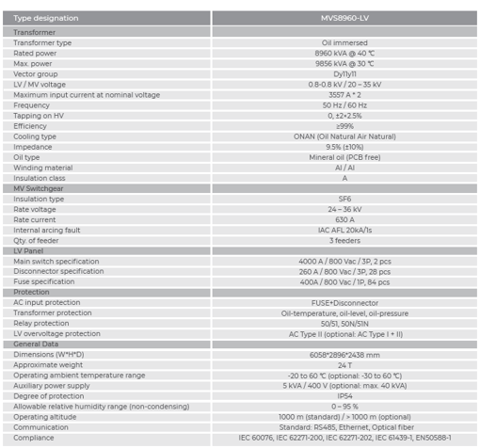
Table 16 Power Station Model
More details of the power stations features can be found on ref [38].

CLIENT STATION
The main purpose of the building is to house a Medium Voltage switchgear room the Low Voltage Panel rooms, and the auxiliary transformer room.
The Medium Voltage switchgear room consists of three Production Substation feeders, one Aux TF feeder and one MV incomer feeder.
The main characteristics of the MV switchgear are Rated Voltage 36.0 kV
- Test Voltage 36.0 kV
- Operating Voltage 33 kV
- Rated frequency 50 Hz
The MV outcomer feeders connect to the production substations through the following routes
- Production substation feeder 1– Substation 1 – Substation 2
- Production substation feeder 2– Substation 3 – Substation 4
- Production substation feeder 3– Substation 5 – Substation 6
The MV incomer feeder connects to a lifting station 33/132 kV out of the scope of this project.
The Control will be located in this station, in the Low Voltage Panel rooms, and, from there, the control and management of the PV plant will be centralized.

PV STRUCTURE DETAILS
The Fixed Structures selected for the PV plant are the following,
Structure  Type | Layout | Tilt | Dimensions | Total Number  of Structures
1 | 2 Portrait 2Vx14  (1 String x 27 modules) | ±20° | 16.188x4.576 m | 216
2 | 2 Portrait 2Vx27  (2 Strings x 54 modules) | ±20° | 31.242x4.576 m | 2,156
Table 17 PV Structure Model

EARTHING SYSTEM
The purpose of the protection grounding is to eliminate the possibility of any electric dynamic situation with any conductive surface that humans can get in touch with. By creating a system with all its surfaces connected in a grounding kit, accident risks are eliminated. An earthing study will be performed in order to determine in detail the final design of the earthing system.
So, the basic units that will be connected to the earthing system concisely presented below:
- The foundation beams of the mounting system are rammed at the calculated depth after required studies in the ground thus providing an excellent grounding system that protects all the parts of the mounting structure. Moreover, all the foundation beams were connected, directly or via equipotential connections, to the main earthing conductor network.
- The perimeter of the modules’ area, via Cupper or Galvanized Steel Conductors, will be connected to the earthing system in order to create a network that will provide grounding and protection from possible electric leakage. The conductor will be placed at a 60cm depth in order to maximize its connection with the ground and to preserve the grounding steady throughout the year since there is always moisture at 60cm depth.
- Power Station earthing, each production Power Station will have an outside ring of earthing conductor placed at its perimeter. All parts shall be connected with two ways towards the grounding ring ensuring, in this way, the availability of the system and reducing the resistance of the plant.
- Equipotential connections, all conductive surfaces which are above the earth level shall be connected to the earthing system and will be equipotentialy connected using appropriate connectors in order to avoid chemical corrosions and thus to ensure the endurance of the grounding system.
- The String Inverters and Low Voltage Panels will be grounded through grounding cable to the earthing system.
- Middle mounting structure tables will be equipotential connected with rest of structure.
In all production Power Stations, every production transformer, MV board and inverter will be grounded through Copper Conductors, respectively with the perimeter grounding Copper Conductor, in order to withstand the maximum short circuit.
More details of the grounding details can be found on ref [23].

CABLING
The transfer of the produced energy from the PV Modules to Grid, will be made through the cables listed below.
PV Modules will be connected to String Inverters with solar cables that will be placed into tubes, where required, in order to protect the cables from being exposed to sharp objects and solar irradiation.
The connection from the String Inverters to General Low Voltage Panel will be made through not buried cables. And the connection from this Low Voltage Panel to the substation will be made through cables that will be buried in trenches and will be placed into tubes at both endings, if required by design.
Finally, the connection from the General Low Voltage Panel to Production Power Station will be made through MV cables that will be buried in trenches and will be placed into tubes at both endings, if required by design.
The table below shows the type, nominal voltage and cross section of each cable described above.

 | Cable Type | Nominal Voltage | Cross Section (mm²)
Solar Cable | CU H1Z2Z2-K | 1.5 kV | 6 mm2
String Inverter to General LV Panel | Multipolar Copper  AC Cable | 0.6/1 kV | 3x120 + 70 mm2
String Inverter to Transformer | AL/XLPE/PVC | 0.6/1 kV | 400 mm2
Medium Voltage Cables | AL/XLPE/CWS/PVC | 19/33 kV | 240/400 mm2
Table 18 Cabling Characteristics
Cross section are calculated in order to optimize the voltage drop and cable losses, in references [28], [29], [30] and [31],according to layout and schematics in references [20], [21], [22], [26] and [27].

CABLE ROUTING
According to the requirements of each trench, which is determined by the cables that need to be buried into, the table below represents the most typical trench dimensions. The cables shall be buried with minimum depth of 70 cm.
Trenches | Dimensions (Width x Depth)
Cu string cables in ducts +  Grounding | 50 x 70 to 90 cm (one or two layers of ducts)
LV AC cable in ducts + Cu string cable in ducts + Grounding | 70 x 120 to 160 cm (one or two layers of LV-AC cables I ducts and one or two layers of Cu string cables in ducts)
Medium voltage cables | 40 to 100 x 140 to 150 cm (one layers of MV cables directly buried)
Medium voltage cables + communication cables | 40 to 100 x 140 to 150 cm (one layers of MV cables directly buried + one or two layer of communication cables in ducts)
LV for auxiliary supply +  Communication in ducts +  Grounding | 67 x 73 to 83 cm
Table 19 Typical Trench Dimensions
Typical trenches and trenches routes in the whole site are shown in references [10], [11] and [12].

LIGHTNING – OVERVOLTAGE PROTECTION
In order to protect the sensitive equipment, surge arresters are installed on all following levels:
- Inverter DC Inputs.
- Inverter AC outputs.
- GLVP Output
Each String Inverter has a system of surge arresters at both AC and DC side.

MONITORING SYSTEM
The Control system consist of one main Controller unit located in the Client Substation of the Solar Power Plant and peripheral units located in Production Power Station areas.
Data are available through local SCADA servers and online server by remote access.
Monitoring systems allow visualisation of PV production, inverter status, substation and switches status, power meter parameters and meteo data.
Architectural systems is represented in reference [xx]
Meteo System includes two autonomous weather station close to the main substation and one of the substations consisting of one pyranometer, one module temperature sensor, one soil dust IQ sensor, one luft sensor and one albedometer. The rest of the sensors are distributed throughout the PV Plant.
In the meteo sensor layout drawing, reference [33], are represented the position of these autonomous wethar station and sensors.

SECURITY SYSTEM
Haunton site according to the topographic layout will need a security fence of 7100 m. The perimeter fence needs to be enhanced by a security system, even though it will be constructed with characteristics that ensure quality.
The alarm system shall be designed to protect the facilities from unauthorized entrance and/or infraction. The alarm system shall include all equipment (magnetic contacts at all doors, gates and windows, control panels, sirens etc) to cover all the essential parts of the Solar Farm (main gate, fence perimeter, Inverter Stations, Main Substation, etc).
There will be a camera located near the client station, each of the productions substations and at the six access gates to the plant. The PTZ cameras will be connected either with fibre optical cable or Ethernet cable and be terminated to the closer security and network panel.
Fence will be protected by a sensitive fiber optic system.
Architectural security system and Security system layout are shown in references [34] and [35]

FENCE
The fence installation has followed the end of all earthworks. It covers the length of the perimeter of each site. It will consist of steel grid mesh and wood fence poles that will be installed in a distance according to structural calculations ref [x].
The fence consists of the following materials:
- Wood fence poles 2.50m high.
- Wire: 2.5mm thickness.
- Mesh size: 25x25 cm.
- Heavy duty Door 4.00 m wide.
The doors will have a 4.00m width in order to allow easy access of vehicles and heavy trucks on site and will be in accordance with the rest of the fence.
The fence drawing is in reference [5],

FIRE ALARM
The PV plant will be enhanced also with a unified fire detection system. Some components as hand fire extinguishers, fire detectors and smoke detectors will be placed.

ACCESS ROAD
The access to the Solar Power Plant and to each Power Station Building will be enabled through Access Roads.
The Internal Access Road will be 3.5m width and a radius of curvature of 12m. It will be constructed by gravel and there will be space for turnover in each Power Station Building, so that heavy trucks and vehicles could easily maneuver.
The details of access road are in reference [6],

FOUNDATIONS
The Power Stations are installed in foundations proper by design, in order for the equipment to be functional.
The materials which being used are in accordance to the applied and local regulations and the conditions on site. For the design of the Power Stations’ foundations there are some alternative solutions:
- Reinforced concrete structure by concrete pouring
- Reinforced concrete structure with use of precast concrete members and steel sections.
Drawings and calculations reports are detailed in references [13] to [15]

GRID CONNECTION
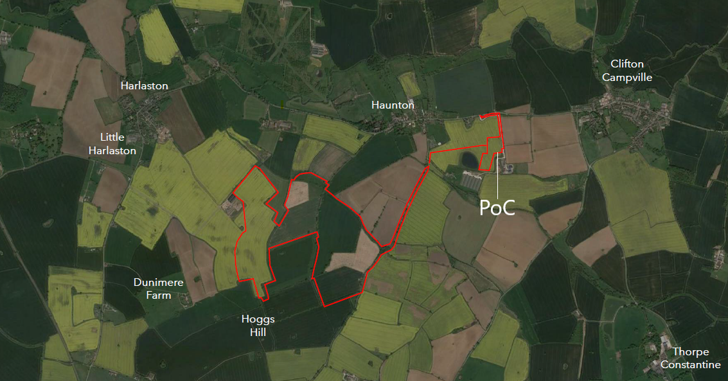
Figure 3 Point of connection
The grid connection point is located approximately 1.2km to the north east of the main, panelled area of the site.

PERMANENT FACILITIES
For the operational period of the PV Power Plant a number of buildings are being constructed in order to ensure the control, availability of spare parts and safety of the Power Plant.

CONSTRUCTION FACILITIES
A compound area will be set up close to the Entrance Gate of the PV Power Plant. It will be accessed through the access road and will be the place where heavy trucks are going to deliver all necessary equipment. Container buildings or ISO boxes will be used as Site Offices and workers’ rest area.

REFERENCES
- Haunton Civil Design Criteria. Ref 227-007-R-C-00001
- Haunton Electrical Design Criteria. Ref 227-007-R-E-00001
- Haunton Communication Design Criteria. Ref 227-007-R-I-00001
- Haunton General Layout. Ref 227-007-D-C-10101
- Haunton Perimeter Fence & Gate drawing detail
- Haunton PV Roads Layout. Ref 227-007-D-C-10310
- Haunton Drainage System PV Road. Ref 227-007-D-C-10402
- Haunton Support Structure Layout Drawing. Ref 227-007-D-C-10501
- Haunton Power Station - Foundations (MV Skid). Ref 227-007-D-C-10801
- Haunton Electrical Trenches-Section Type. Ref 227-007-D-C-11014
- Haunton Cable Trenches Layout-MV Power Cables. Ref 227-007-D-C-40323
- Haunton Cable Trenches Layout- Rest of Power Cables and FO. Ref 227-007-D-C-40327
- Haunton Inverter Foundation. Ref 227-007-D-C-11011
- Haunton Weather Station Foundation. Ref 227-007-D-C-11012
- Haunton I&C sensor foundation. Ref 227-007-D-C-11014
- Haunton Drainage Study. Ref 227-007-F-C-20400
- Haunton Roads Study. Ref 227-007-F-C-20300
- Haunton Power Station Layout. Ref 227-007-D-E-40311
- Haunton Inverter Layout. Ref 227-007-D-E-40314
- Haunton Cable Layouts - MV Cables. Ref 227-007-D-E-40321
- Haunton Cable Trench Layout - LV DC & AC Cables. Ref 227-007-D-E-40322
- Haunton LV AC DC and Communication Cables Layout. Ref 227-007-D-E-40323
- Haunton Earthing Grid Layout and details. Ref 227-007-D-E-40410
- Haunton PV Blocks Layout. Ref 227-007-D-E-40310
- Haunton String Connection Details. Ref 227-007-D-E-40328
- Haunton Overall Electrical Single Line Diagram. Ref 227-007-D-E-11010
- Haunton DC Single Line Diagram. Ref 227-007-D-E-011013
- Haunton DC Cables Ampacity Calculation. Ref 227-007-F-E-00100
- Haunton LV AC Cables Ampacity Calculation. Ref 227-007-F-E-00102
- Haunton MV Cables Ampacity Calculation. Ref 227-007-F-E-00103
- Haunton Auxiliary Loads Calculation. Ref 227-007-F-E-00110
- Haunton PR Calculation Report. Ref 227-007-F-E-00104
- Haunton Control System Architectural Diagram. Ref 227-007-D-I-00300
- Haunton Security System Layout. Ref 227-007-D-I-40301
- Haunton Fiber Optic Splice Plan. Ref 227-007-D-I-00303
- Module Datasheet: Tiger Neo N-type 72HL4-BDV 560-580 Watt
- Inverter Datasheet: Sungrow SG350HX
- Power Station Datasheet: MVS8960-LV
- Power Station Technical Description: MVS8960-LV

